Q1 :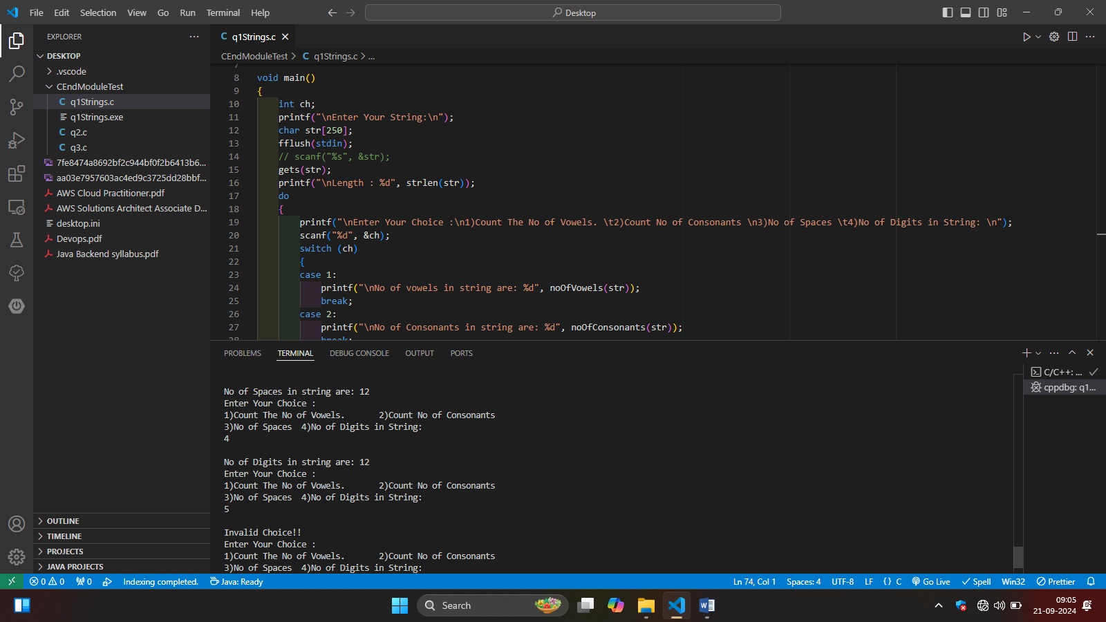

#include <stdio.h>

#include <string.h>

int noOfVowels(char[]);

int noOfConsonants(char[]);

int noOfSpaces(char[]);

int noOfDigits(char[]);

void main()

{

    int ch;

    printf("\nEnter Your String:\n");

    char str[250];

    fflush(stdin);

    // scanf("%s", &str);

    gets(str);

    printf("\nLength : %d", strlen(str));

    do

    {

        printf("\nEnter Your Choice :\n1)Count The No of Vowels. \t2)Count No of Consonants \n3)No of Spaces \t4)No of Digits in String: \n");

        scanf("%d", &ch);

        switch (ch)

        {

        case 1:

            printf("\nNo of vowels in string are: %d", noOfVowels(str));

            break;

        case 2:

            printf("\nNo of Consonants in string are: %d", noOfConsonants(str));

            break;

        case 3:

            printf("\nNo of Spaces in string are: %d", noOfSpaces(str));

            break;

        case 4:

            printf("\nNo of Digits in string are: %d", noOfDigits(str));

            break;

        case 0:

            printf("\nExiting..");

            break;

        default:

            printf("\nInvalid Choice!!");

            break;

        }

    } while (ch != 0);

}

int noOfVowels(char str[])

{

    int cnt = 0;

    for (int i = 0; str[i] != '\0'; i++)

    {

        if (str[i] == 'a' || str[i] == 'e' || str[i] == 'i' || str[i] == 'o' || str[i] == 'u' || str[i] == 'A' || str[i] == 'E' || str[i] == 'I' || str[i] == 'O' || str[i] == 'U')

        {

            cnt++;

        }

    }

    return cnt;

}

int noOfConsonants(char str[])

{

    int cnt = 0;

    for (int i = 0; str[i] != '\0'; i++)

    {

        // if ((str[i] != 'a' || str[i] != 'e' || str[i] != 'i' || str[i] != 'o' || str[i] != 'u' || str[i] != 'A' || str[i] != 'E' || str[i] != 'I' || str[i] != 'O' || str[i] != 'U'))

        if (str[i] == 'a' || str[i] == 'e' || str[i] == 'i' || str[i] == 'o' || str[i] == 'u' || str[i] == 'A' || str[i] == 'E' || str[i] == 'I' || str[i] == 'O' || str[i] == 'U')

        {

            continue;

        }

        else if ((str[i] >= '0' && str[i] <= '9') == 0 && str[i] != ' ')

        {

            cnt++;

        }

    }

    return cnt;

}

int noOfSpaces(char str[])

{

    int cnt = 0;

    for (int i = 0; str[i] != '\0'; i++)

    {

        if (str[i] == ' ')

        {

            cnt++;

        }

    }

    return cnt;

}

int noOfDigits(char str[])

{

    int cnt = 0;

    // int len = strlen(str);

    for (int i = 0; str[i] != '\0'; i++)

    // for (int i = 0; i <= len; i++)

    {

        if (str[i] >= '0' && str[i] <= '9')

        {

            cnt++;

        }

    }

    return cnt;

}

C:\Users\bhagv\Desktop> cmd /C "c:\Users\bhagv\.vscode\extensions\ms-vscode.cpptools-1.21.6-win32-x64\debugAdapters\bin\WindowsDebugLauncher.exe --stdin=Microsoft-MIEngine-In-h3f02afo.fvu --stdout=Microsoft-MIEngine-Out-xtoqcsqi.bjj --stderr=Microsoft-MIEngine-Error-k21dtizd.1n4 --pid=Microsoft-MIEngine-Pid-fpx0dixz.t30 --dbgExe=C:\TDM-GCC-64\bin\gdb.exe --interpreter=mi "

Enter Your String:

Hello I am Bhagvat Mutthe Roll no 96 My contact no is 8408921072

Length : 64

Enter Your Choice :

1)Count The No of Vowels. 2)Count No of Consonants

3)No of Spaces 4)No of Digits in String:

1

No of vowels in string are: 14

Enter Your Choice :

1)Count The No of Vowels. 2)Count No of Consonants

3)No of Spaces 4)No of Digits in String:

2

No of Consonants in string are: 26

Enter Your Choice :

1)Count The No of Vowels. 2)Count No of Consonants

3)No of Spaces 4)No of Digits in String:

3

No of Spaces in string are: 12

Enter Your Choice :

1)Count The No of Vowels. 2)Count No of Consonants

3)No of Spaces 4)No of Digits in String:

4

No of Digits in string are: 12

Enter Your Choice :

1)Count The No of Vowels. 2)Count No of Consonants

3)No of Spaces 4)No of Digits in String:

5

Invalid Choice!!

Enter Your Choice :

1)Count The No of Vowels. 2)Count No of Consonants

3)No of Spaces 4)No of Digits in String:

0

Exiting..

C:\Users\bhagv\Desktop>

Q3

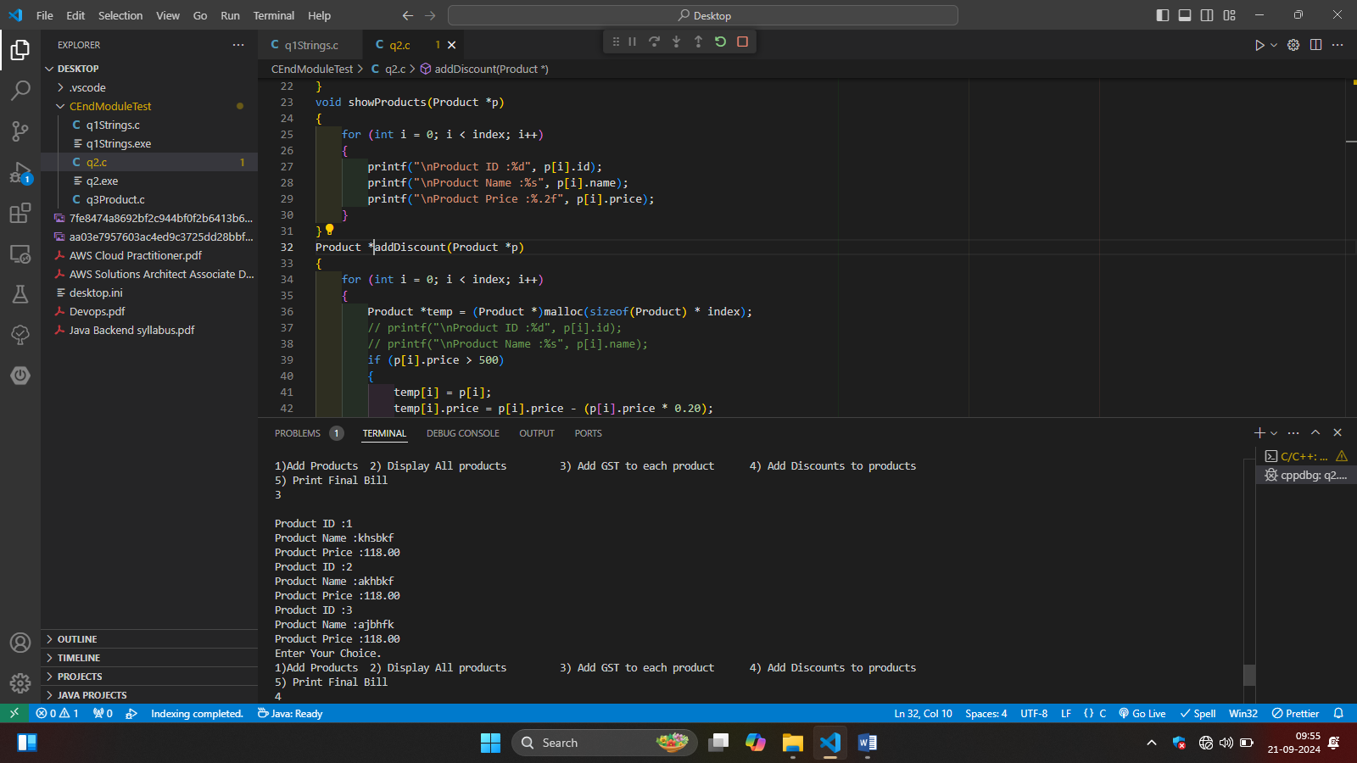

#include <stdio.h>

#include <stdlib.h>

int size = 5, index = 0;

typedef struct Product

{

    int id;

    char name[20];

    float price;

} Product;

void getProducts(Product \*p, int usize)

{

    for (int i = 0; i < usize; i++, index++)

    {

        printf("\nEnter Product ID :");

        scanf("%d", &p[index].id);

        printf("\nEnter Product Name :");

        fflush(stdin);

        gets(p[index].name);

        printf("\nEnter Product Price :");

        scanf("%f", &p[index].price);

    }

}

void showProducts(Product \*p)

{

    for (int i = 0; i < index; i++)

    {

        printf("\nProduct ID :%d", p[i].id);

        printf("\nProduct Name :%s", p[i].name);

        printf("\nProduct Price :%.2f", p[i].price);

    }

}

Product \*addDiscount(Product \*p)

{

    Product \*tempd = (Product \*)malloc(sizeof(Product) \* index);

    for (int i = 0; i < index; i++)

        tempd[i] = p[i];

    for (int i = 0; i < index; i++)

    {

        if (p[i].price > 500)

        {

            tempd[i].price = p[i].price - (p[i].price \* 0.20);

            // printf("\nProduct Price With Discount 20%% is:%.2f", p[i].price);

        }

        return tempd;

    }

}

Product \*addGST(Product \*p)

{

    Product \*temp = (Product \*)malloc(sizeof(Product) \* index);

    for (int i = 0; i < index; i++)

    {

        temp[i] = p[i];

        temp[i].price = p[i].price + (p[i].price \* 0.18);

    }

    return temp;

}

void displayBill(Product \*p)

{

    Product \*temp;

    temp = addGST(p);

    for (int i = 0; i < index; i++)

        p[i] = temp[i];

    temp = addDiscount(p);

    for (int i = 0; i < index; i++)

        p[i] = temp[i];

    float totalAmount;

    printf("\n\tFinal Bill :");

    for (int i = 0; i < index; i++)

    {

        printf("\nProduct %d", i + 1);

        printf("\nProduct ID :%d", p[i].id);

        printf("\nProduct Name :%s", p[i].name);

        printf("\nProduct Price :%.2f", p[i].price);

        totalAmount += p[i].price;

    }

    printf("\n\tTotal Bill : %.4f\n", totalAmount);

}

void main()

{

    int sUser;

    Product \*prod = (Product \*)malloc(sizeof(Product) \* size);

    int ch;

    do

    {

        Product \*temp;

        printf("\nEnter Your Choice.\n1)Add Products \t2) Display All products \t3) Add GST to each product \t4) Add Discounts to products \n5) Print Final Bill\n");

        scanf("%d", &ch);

        switch (ch)

        {

        case 1:

            printf("\nEnter How many products do you want to add : ");

            scanf("%d", &sUser);

            if (sUser > size)

            {

                size = sUser;

                temp = (Product \*)realloc(prod, sizeof(Product) \* size);

                if (temp == NULL)

                {

                    printf("\n\nReallocation Failed");

                    return; /\* code \*/

                }

                else

                {

                    prod = temp;

                }

            }

            getProducts(prod, sUser);

            break;

        case 2:

            showProducts(prod);

            break;

        case 3:

            temp = addGST(prod);

            showProducts(temp);

            // free(temp);

            break;

        case 4:

            temp = addDiscount(prod);

            showProducts(temp);

            //

            break;

        case 5:

            displayBill(prod);

            break;

        case 0:

            printf("\nExiting....");

            free(temp);

            free(prod);

            break;

        default:

            printf("\nInvalid Choice!!");

            break;

        }

    } while (ch != 0);

}

C:\Users\bhagv\Desktop> cmd /C "c:\Users\bhagv\.vscode\extensions\ms-vscode.cpptools-1.21.6-win32-x64\debugAdapters\bin\WindowsDebugLauncher.exe --stdin=Microsoft-MIEngine-In-gno4ojy2.jha --stdout=Microsoft-MIEngine-Out-auv1skpr.rum --stderr=Microsoft-MIEngine-Error-fdk4whzg.pij --pid=Microsoft-MIEngine-Pid-pwljhank.bwf --dbgExe=C:\TDM-GCC-64\bin\gdb.exe --interpreter=mi "

Enter Your Choice.

1)Add Products 2) Display All products 3) Add GST to each product 4) Add Discounts to products

5) Print Final Bill

1

Enter How many products do you want to add : 3

Enter Product ID :1

Enter Product Name :kabfj

Enter Product Price :100

Enter Product ID :2

Enter Product Name :ajfha

Enter Product Price :700

Enter Product ID :3

Enter Product Name :jhaejha

Enter Product Price :550

Enter Your Choice.

1)Add Products 2) Display All products 3) Add GST to each product 4) Add Discounts to products

5) Print Final Bill

2

Product ID :1

Product Name :kabfj

Product Price :100.00

Product ID :2

Product Name :ajfha

Product Price :700.00

Product ID :3

Product Name :jhaejha

Product Price :550.00

Enter Your Choice.

1)Add Products 2) Display All products 3) Add GST to each product 4) Add Discounts to products

5) Print Final Bill

3

Product ID :1

Product Name :kabfj

Product Price :118.00

Product ID :2

Product Name :ajfha

Product Price :826.00

Product ID :3

Product Name :jhaejha

Product Price :649.00

Enter Your Choice.

1)Add Products 2) Display All products 3) Add GST to each product 4) Add Discounts to products

5) Print Final Bill

4

Product ID :1

Product Name :kabfj

Product Price :100.00

Product ID :2

Product Name :ajfha

Product Price :700.00

Product ID :3

Product Name :jhaejha

Product Price :550.00

Enter Your Choice.

1)Add Products 2) Display All products 3) Add GST to each product 4) Add Discounts to products

5) Print Final Bill

5

Final Bill :

Product 1

Product ID :1

Product Name :kabfj

Product Price :118.00

Product 2

Product ID :2

Product Name :ajfha

Product Price :826.00

Product 3

Product ID :3

Product Name :jhaejha

Product Price :649.00

Total Bill : 1593.0000

Enter Your Choice.

1)Add Products 2) Display All products 3) Add GST to each product 4) Add Discounts to products

5) Print Final Bill

6

Invalid Choice!!

Enter Your Choice.

1)Add Products 2) Display All products 3) Add GST to each product 4) Add Discounts to products

5) Print Final Bill

0

Exiting....

C:\Users\bhagv\Desktop>

Q2:

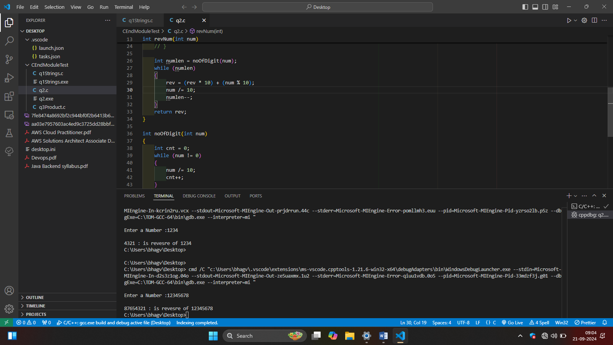#include <stdio.h>

int revNum(int);

int noOfDigit(int);

void main()

{

    int num;

    printf("\nEnter a Number :");

    scanf("%d", &num);

    int rev = revNum(num);

    printf("\n%d : is revesre of %d", rev, num);

}

int revNum(int num)

{

    int rev = 0;

    // while (num)

    // {

    //     rev = (rev \* 10) + (num % 10);

    //     num = num / 10;

    //     rev = (rev \* 10) + revNum(num);

    //     return rev;

    // }

    int numlen = noOfDigit(num);

    while (numlen)

    {

        rev = (rev \* 10) + (num % 10);

        num /= 10;

        numlen--;

    }

    return rev;

}

int noOfDigit(int num)

{

    int cnt = 0;

    while (num != 0)

    {

        num /= 10;

        cnt++;

    }

    return cnt;

}